Title Goes Here: The Third International Conference on Environmental Science and Technology

Author 1, Author 2
Affiliation
Author 3
Affiliation

Abstract
Replace this text with your abstract of one paragraph, no more than 250 words. The abstract is centered, justified, and indented 0.63 cm on the left and right. Do not replace or delete the word “Abstract” above which is centered at the top.

Keywords: Enter up to five keywords on this line, alphabetized and separated by semicolons.

Introduction
Use this template to enter text. The extended abstract includes as Abstract, Introduction, Method, Result, Discussion & Conclusions, Acknowledgements, and References. The extended abstract should not exceed 5 pages including any. Detailed specifications are found in the document “Instructions for Authors.”
Secondary heading
Begin to enter your text here. This is the standard paragraph format. Use only one space after the period at the end of a sentence. Do not insert an extra line space between paragraphs.
Margins are set for letter size the extended abstract (8 ½ x 11 inches). Margins are 1.9 cm top and bottom, and 1.78 cm right and left. To see margin specifications, go to the File menu, then Page Setup. To change units of measurement from centimeters to inches, go to the Tools menu, then Options, and choose the General tab.
Format
Times New Roman is used throughout. Font settings for the abstract and body of the extended abstract are 10 point, single spaced, regular type, justified. The main title is 14 point, bold, centered. The first line paragraph indent is 0.32 cm. Section heads are 12 point bold, centered. Subheads are 10 point italic, flush left.

Preparing Your Extended Abstract
The template
Copy the template to your hard drive. To rename the document, click on Save As under the File menu. The name of the new file should be the last name of the first author, and the date, followed by the file extension word.doc. Be sure to specify the location on your hard drive where you want the file to be saved. At this point you are ready to type your paper directly into the new file or copy and paste prepared text into it.
Title, author(s), affiliation(s)
To type the title of your paper on the first page, highlight the word Title at the top of the template and replace it by typing in your paper title. Use capital letters for the first letter of every word in the title, except lower case for prepositions (for, of, in, by, etc.), articles (a, an, the), and conjunctions (and, but, or). Be sure to delete all the letters in the template title but do not delete the paragraph return code at the end.
Similarly, replace Author 1, Author 2, etc. on the template with the name or names of the author or authors. Type the first name or initials first, followed by the last name. Add or delete lines as needed. Affiliation is in italics, centered under the author’s name. Highlight the word and type in the author’s institution, city, and country.
Section headings and secondary headings
If your text starts with a section heading, you may highlight the word “Introduction” and change it, or you may wish to leave it as it is. Section heads are 12 point bold, centered, with an extra 6 point line spacing between it and the beginning of the text. Use capital letters for the first letter of every word in this heading.
Secondary heads are 12 point regular italic, flush left. Capital letters are used only for the first letter of the first word of secondary heads. The styles are “Section Head” and “Secondary Head”. If your text starts without a heading, delete the word “Introduction” and begin entering your text.
Text
The font you will use is 10 point Times New Roman regular. The style is “Paragraph”.
Figures
Figures and photographs must fit within one column or within the margins of the full page. Number figures consecutively and place them as close as possible to the first reference to them in the text. Use the “Figure Caption” style, 9 point Times New Roman, regular. Captions give a brief description or identification and are placed below the figure. Leave two blank lines between the caption and the text below.
Scan all photographs and other figures separately as high resolution jpeg or tif files in black and white. Photographs and grayscale drawings must be scanned at 300 ppi (same as dpi); line art is scanned at 1200 ppi. You may place your scanned images directly in the Word and figures as separate electronic files.

Results
The respective up to present day regularities are outlined for southern forest-tundra landscape zone (Figure 1).
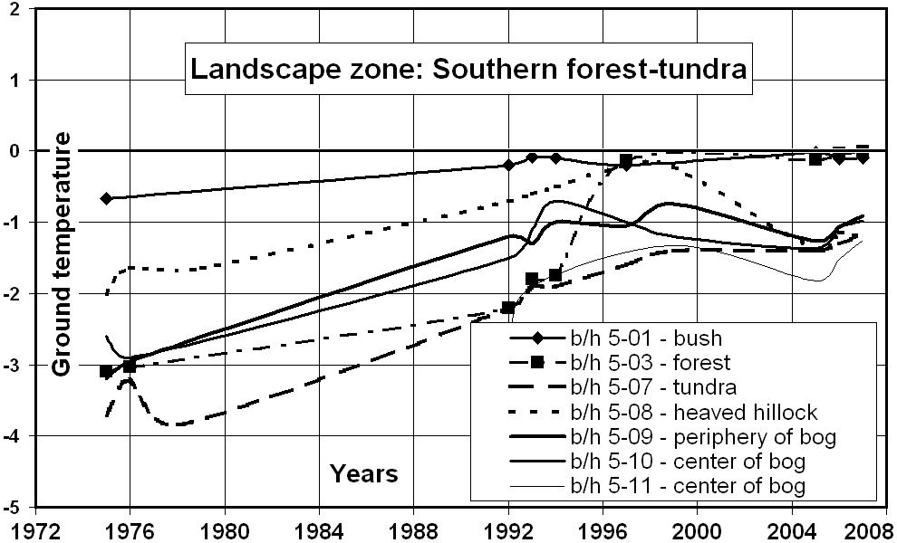
Figure 1. Ground temperature

Equations
You may access the Equation Editor in Word by going to the Insert menu, then to Object, and then to the Create New tab. Equations are not indented. Number them consecutively with the number in parentheses at the end of the line.
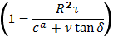
K_{t} = ⁴ k₁ (1)

Do not use the Equation Editor between words in lines of running text. Simple equations and mathematical symbols can be inserted in Word by using Unicode characters. To access them, go to Insert on the menu bar, and then to Symbol. There you can scroll to find the characters you want. Click on the character box; then hit “insert,” and the character will appear at the insertion point in your document. You can use superscript and subscript by highlighting the character in the text, going to Format on the menu bar, then to Font, and then checking the box for superscript or subscript.

Tables
Use the Table command on the menu bar. Place tables close to the first reference to them in the text. Number them consecutively. Table numbers and headings go above the table. Use only horizontal rules: one at the head of the table, one below the column headings, and one at the foot of the table. Align all headings and columns to the left.
The type style for tables, table headings, and table explanations is 9 point Times New Roman. Table 1 is an example of a one-column table; Table 2 extends across the full width of the page. To make tables that spread across the full page, you must specify your preferred table width. Place your cursor anywhere in your table and then go to the Table menu and choose Table Properties. Click on the Table tab, check the Preferred Width box, and specify 7 inches. You may then move the table by dragging with the little box that appears at the upper left corner of the table. Page-wide tables should be placed either at the top or the bottom of the page to avoid breaks in the text.

Headers and Footers
Headers and footers are embedded in the template. Do not adjust page numbers or positions (Table 1).
Table 1. Table heading goes here.
 | Th-03 | Th-10 | Th-12 | Th-14 | Th-20
20/06/19 | 1.09 | 1.10 | 3.00 | 4.30 | 2.10
21/06/19 | 1.01 | 1.09 | 3.00 | 4.10 | 2.00
22/06/19 | 1.10 | 1.11 | 3.10 | 4.50 | 2.20
23/06/19 | 1.12 | 1.21 | 3.30 | 4.70 | 2.40
24/06/19 | 1.09 | 1.09 | 1.09 | 1.09 | 1.09

Headers are placed differently on even- and odd-numbered pages. On the odd-page header, replace the words “Author’s Name” with the name of the author as the name appears under the title. For two authors, enter both full names; for more than two authors, enter “First Author et al.”(fig.1)

Acknowledgments
You may include acknowledgments by replacing this paragraph. This section goes just before the References.

References
Consistency of style is very important in citations in the text and in the list of references.
Citations in the text
Examples are as follows:
- One author: (Smith, 1989).
- Two authors: (Smith & Jones, 1990).
- More than two authors: (Smith et al., 1991).
- Date only: As mentioned by Smith & Jones (1990).
- Multiple citations, ordered by date, separated by commas: (Smith, 1989; Smith & Jones, 1990, Smith et al., 1991).
- Same year by same author: (Smith, 1989a, b) or (Smith & Jones, 1990; Smith, 1992a, b).
- Unpublished works: (Smith, in press), (Smith, in prep.), (Smith, unpubl.), (Smith, pers. com.).
- Figures: (Figure 1) or (Figures 1, 2). In running text, refer to Figure 1, Figure 2.
List of references
All references cited in the text are listed at the end of the paper. The format is the same as the text with hanging indents set at 96. Do not use tabs. You can create hanging indents in two ways: 1) select the paragraph and drag the “hanging indent” marker at the left of the vertical toolbar to the third tick mark, or 2) select the paragraph, then under Format on the menu bar go to Paragraph and select the Indents and Spacing tab; in the box marked Special, choose “hanging,” and in the box marked By, type 0.95cm.
References are listed alphabetically, always starting with author’s last name, initials, and year of publication.
• One author: Smith, J.R. 1972.
• Two authors: Smith, J.R. & Jones, P.D.
• More than two authors; Smith, J.R., Jones, P.D. & Brown, A.S. 1983.
Journal article, book
Last name, initials. Year. Title of article. Title of journal (number if part of a series), volume number (issue number): page numbers.
Murton, J.B. & French, H.M. 1994. Geography landscape in western Canada. Canadian Journal of Earth Sciences 31: 737-747.
Pavlov A.V. & Malkova G.V. 2005. Contemporary climate changes in the northern Russia: Album of general maps. Novosibirsk, Academic publishing house “Geo”, 54 p. (in Russian)

